Client | [İ2İ System]
Project Name | [EnteroCELL]

Table of Contents
1 Document Overview 3
1.1 Scope & Purpose 3
1.2 Version Numbers 3
1.3 Audience 3
1.4 Document Structure and Special Conventions 4
1.5 Definitions, Symbols and Abbreviations 4
1.6 Reference Documents 5
2 Test Execution 6
2.1 Test Case Index 6
2.1.1 TC_001: Login (Partner Employee) 7
2.1.2 TC_002: Sales Partner Activation 8
3 Test Results 9
3.1 Findings History 9
4 Appendix - 1 10
4.1 Defect Severity Level Definitions 10
Appendix - 2 11
Document Control 11

Document Overview

Scope & Purpose

The scope of this document is to provide i2i Internal Acceptance Test Cases and their results on [web] area which forms a critical part of the [EnteroCELL] Program/Project of [İ2İSystems].

Version Numbers
The Specification, prepared by i2i Systems and Consultancy (i2i), follows a versioning scheme similar to 3GPP specifications. In case of a change in the initial release of the EnterCELL project, the following steps are applied, and the version will be 1.1.1 as follows:
x the first digit:
1 presented for information;
2 presented for approval;
3 or greater indicates approved document under change control.
y the second digit is incremented for all changes of substance, i.e. technical enhancements, corrections, updates, etc.
z the third digit is incremented when editorial only changes have been incorporated in the document.

Audience

The document may be read by the below audience;

- Business departments
- Business/System analysts
- Solution/System Architects
- Program/Project Managers

Document Structure and Special Conventions
In the implemented application, if there is any complexity, explanations should be provided at specific points in the project. For example, in the "Remaining Usages" section on the main page of the project, there is an additional plugin available to provide more detailed explanations and clarify everything briefly for the user.

Definitions, Symbols and Abbreviations

TERM | DESCRIPTION
API | Application Programming Interface
ASN.1 | Abstract Syntax Notation 1. An abstract syntax notation, which is used to describe data and data structure.
BGW | Billing Gateway
BRS | Business Requirements Specification
BSS | Business Support System
CDR | Call Data Record – Records in files generated by external network nodes such as MSC, SDP etc.
DWH | Data Ware House
EDIFACT | Electronic Data Interchange For Administration, Commerce and Transport. EDIFACT indicates a format
EIR | Equipment Identity Register
FMS | Fraud Management System
GUI | Graphical User Interface
HTML | Hyper Text Markup Language.
HTTP | Hyper Text Transfer Protocol. Simple stateless protocol used throughout the internet.
IVR | Interactive Voice Response System
Java | An object orientated programming language which is portable between platforms.
MML | Man Machine Language, specifies the command format API of the HLR
OSS | Operations Support System
SAS | System Architectural Specification
SOAP | Simple Object Access Protocol  SOAP is a simple XML-based protocol to let applications exchange information over HTTP
SRS | System Solution Requirements Specification
VAS | Value Added Service
XML | Extensible Markup Language. A widely used standard mark-up language.
XSD | XML Schema Definition. XML Schema is an XML based alternative to DTD. An XML schema describes the structure of an XML document.

Reference Documents
- https://touc.com.tr/entrocell/
- https://github.com/tolgaucar/entrocell-web/
- https://github.com/gkhan5252/EnteroCELL-web-test.git

Test Execution

Test Case Index

2.1.1 TC_001: Login (Partner Employee) 7
2.1.2 TC_002: Dealer Activation - AIM 8

TC_001: Login ()
Short Description: We tested the successful login scenario in the login screen in this test section.…
Scenario Description: We tested what happens when the correct information is entered on the login page, and it logs in.
Pre-Condition: We tested what happens when the correct information is entered on the login page, and it logs in.
Input Data:
For the correct information, the phone number should be 5339635384 and the password should be 12345.
Triggering the Test Case:
- Go to the login page.
- Phone number textbox a whrite “5339635384”
- Password textbox a whrite “12345”
- Login button a press
Output/Result Data:
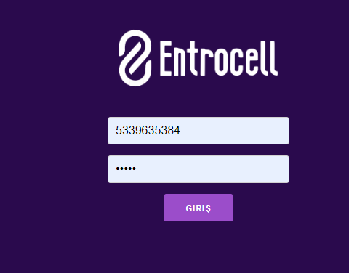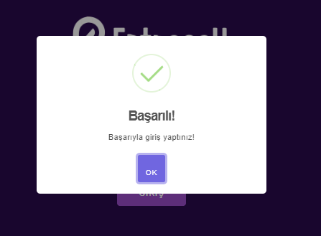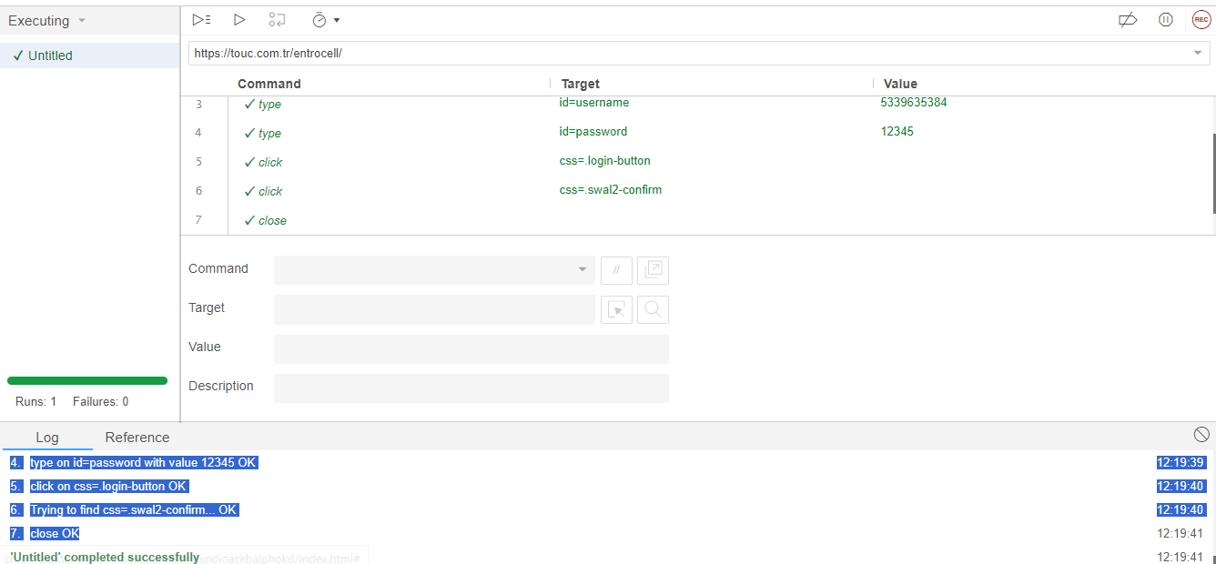
Expected Outputs (Success conditions) | Passed | Finding Id
- 1.open on /entrocell/ OK  - 2.setWindowSize on 1024x546 OK  - 3.type on id=username with value 5339635384 OK  - 4.type on id=password with value 12345 OK  - 5.click on css=.login-button OK12:19:40  - 6.Trying to find css=.swal2-confirm... OK  - 7.close OK | YES

TC_002: login error
Short Description: forcing incorrect login
Scenario Description We looked into whether an error would occur when an incorrect login is attempted, or if it would log in directly. We evaluated many options..
Pre-Condition: I understand, as preliminary information, we can enter a random number for an incorrect login. Thank you!
Input Data:

Login ID:5339635 login id:533963584 login id : 5333963
password: 12345 password:1236 password :1238

Triggering the Test Case:
- [Login]
- User number this number should not be valid.”533963584
- Password :12345
- Password and phone number should not contain correct values at the same time.
- Understood, let's keep the phone number constant and try entering a number other than "12345" for the password.
- Sure, I understand. Let's enter random incorrect values for both the phone number and the password.
.
- Click "login" button.

Output/Result Data:
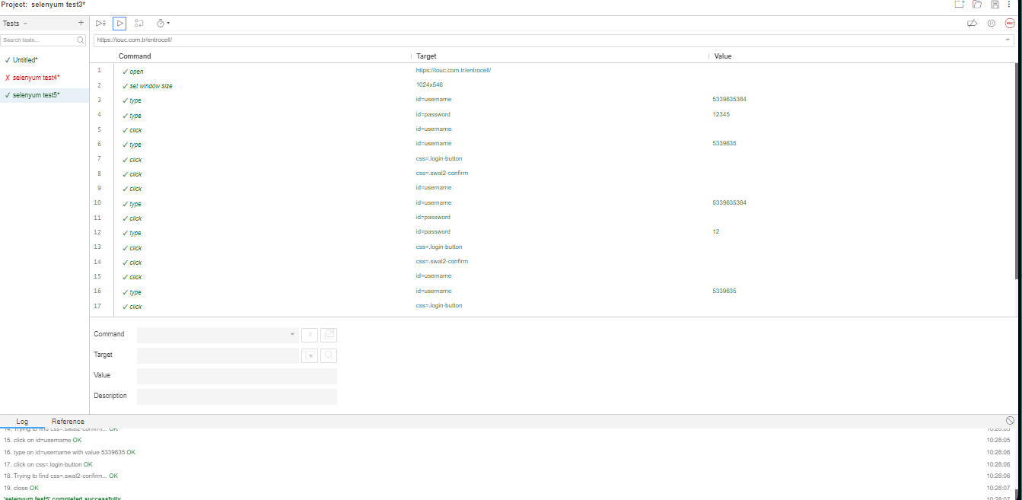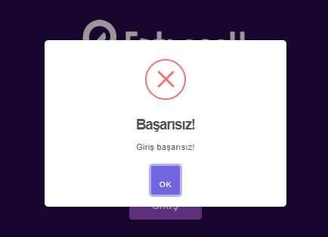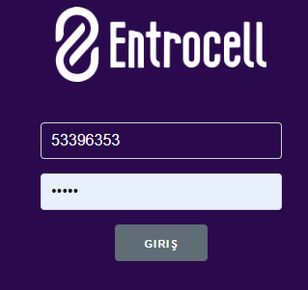
Expected Outputs (Success conditions) | Passed | Finding Id
- 1.open on https://touc.com.tr/entrocell/ OK10:27:57  - 2.setWindowSize on 1024x546 OK10:27:58  - 3.type on id=username with value 5339635384 OK10:27:58  - 4.type on id=password with value 12345 OK10:28:01  - 5.click on id=username OK10:28:02  - 6.type on id=username with value 5339635 OK10:28:03  - 7.click on css=.login-button OK10:28:03  - 8.Trying to find css=.swal2-confirm... OK10:28:03  - 9.click on id=username OK10:28:04  - 10.type on id=username with value 5339635384 OK10:28:04  - 11.click on id=password OK10:28:04  - 12.type on id=password with value 12 OK10:28:04  - 13.click on css=.login-button OK10:28:05  - 14.Trying to find css=.swal2-confirm... OK10:28:05  - 15.click on id=username OK10:28:05  - 16.type on id=username with value 5339635 OK10:28:06  - 17.click on css=.login-button OK10:28:06  - 18.Trying to find css=.swal2-confirm... OK10:28:06  - 19.close OK10:28:07  - 'selenyum test5' completed successfully | YES

Test Results

Findings History

bb(Mantis ID) | Short Defect Description | Opened Date | Status | Severity | Developer/  Tester
1234567 | Error output cannot be made | 25.01.2024 | Open | Critical | Gökhan yapıcı
1234576 | Internet information is not updated when the page is refreshed | 25.01.2024 | Open | Critical | Gökhan yapıcı
12345789 | SMS remaining information is not updated when the page is refreshed | 25.01.2024 | Open | Critical | Gökhan yapıcı
12345679 | Minutes remaining information is not updated when the page is refreshed. | 25.01.2024 | Open | Critical | Gökhan yapıcı

Appendix - 1

Defect Severity Level Definitions

The severity should describe how critical the problem is. This should not describe how difficult it is to fix the problem.
Generally, there are four level of severity: Critical, High, Medium and Low.

Critical: This defect can be fatal for the execution of the system and can cause loss of business functionality and/or money for the customer. For example, if a user interface that is used to activate contracts is not working due to a software error, then this means loss of business for the customer, and the defect should be fixed urgently. Or, An SQL Error gets severity “High”, because it’s a fatal for the execution. But it might be easy to fix it by correcting the statement.

High/Medium: If a defect doesn’t cause loss of business functionality and/or money for the customer, then this can be considered as “High” or “Medium”. For example, a user interface that is used to activate contracts might populate some wrong data on database, but, the activations can be done properly despite this wrong data. The defect can be corrected within a reasonable time period. In the mean time, wrong data can be corrected with manual operations.

Low: Mostly, cosmetic defects are considered as “Low”. These defects don’t cause any loss of business functionality, money or data. The system can work properly, even if the defect is not fixed forever.

Appendix - 2

Document Control

Superseded Documents
- N/A

Change Control & Distribution
Owner | EnteroCELL
Reviewer | Gökhan yapıcı
Approved By | Mennan tekbir
Distribution
File Name | EnteroCELL test.101

Version History
Version | Change Descriptions | Author | Date
1.0.0 | EnteroCELL testing | Gökhan yapıcı | 25/Jan/2024

Approvals
This document requires the following approvals:

Name | Title | Date | Signature | Version
Mennan tekbir | EnteroCELL testing(login) | 25/01/2024 | Gökhan yapıcı | 1.1.1
Menan tekbir | EnteroCell testing(login error) | 25/01/2024 | Gökhan yapıcı | 1.1.1

